a

Guynes Daniel M (Contractor)

[Email address]

Abstract

This document will provide an overview of how the IRS Power Platform Team plans to operate to ensure a high level of governance over the environment with a cyclical approach to ensuring long-term health and modernization of the IRS Power Platform Environment.

power platform governance

IRS Operational Governance Guidelines

# Table of Contents

Table of Contents 1

Table of Figures 2

Document Revision History 3

References 3

Purpose 4

Summary 5

Objectives 6

Elements Of Governance 7

Operational Governance 9

Future State of Power Platform Governance 10

Appendix A: Pipeline API Process 11

# Table of Figures

Figure 1 11

# Document Revision History

|  |  |  |
| --- | --- | --- |
| Editor | Date Edited | Comments |
| Daniel Guynes (contractor) | 1.17.2025 | Initial document creation |
|  |  |  |
|  |  |  |

# References

|  |
| --- |
| Document or Site |
| Instructions for Power Platform Environments.docx |
|  |
|  |

# Purpose

The purpose of this document is to define the governing responsibilities and tasks to be performed by the Power Platform Team (PPT) to maintain a healthy, up to date Power Platform environment. Furthermore, the intent of this document is to provide the operational model of the PPT to ensure continued success in governance currently and into the future.

In this document the Power Platform environment is meant to include Power Apps, Power Automate, and Power BI.

# Summary

The PPT will operate in an Agile methodology, implementing SCRUM with 2-week Sprints to ensure that the PPT is administering the governance laid out in this document. We will use MS Project to implement a Sprint templated project plan. Using the Kanban boards available (built into the template), the PPT will run the two-week sprints in traditional Agile style including a Planning Session at the start of each Sprint, a Retrospective and Review at the end of the Sprint, and a Backlog Grooming near the end of the Sprint.

While all of IRS employees and IRS approved contractors are our customers, our PPT management and M365 management are our stakeholders.

Finally, the PPT will provide expert service to our customer base through Service Now tickets entered by IRS customers regarding the Power Platform environment. This includes but is not limited to:

* Environment creation and amendment.
* Continuous Integration / Continuous Delivery (CI/CD) Pipeline creation and amendment.
* Necessary manual Solution deployment.
* Security Group creation and amendment.
* Power Platform and Pipeline education and instruction.
* Troubleshooting deployment issues.
* Verification and validation of solutions.

# Governance Policies

The IRS Power Platform Team will utilize the Microsoft provided template for Power Platform Governance and implement it according to this section.

## Governance Dashboard

Using the CoE Starter Kit from Microsoft, the IRS PPT will maintain watch over the Power Platform’s governance using a combination of the CoE BI Dashboard and the CoE Power Platform applications.

The CoE Power BI Dashboards provide a real-time glimpse into all core elements of Power Platform, and the CoE Power Platform applications provides the PPT the ability to fix or further identify governance issues.

## Environment Strategy

### Guidelines for Creating Environments

The IRS PPT will use Service Now (a.k.a. IR Works) to provide IRS users the ability to request new Environments. Service Now forms will be created specifically for Environment Requests, which will provide specific questions regarding the intent and the content for the need for a new Environment.

Guidelines will be made available via the IRS Power Platform SharePoint Site pages to assist users in how to fill out the Service Now Power Platform Environment request, as well as definitions of the different environment types (Sandbox, Test, and Prod)

## Guidelines for Administration of Environments

A guideline document (XXX) is available to all Power Platform Team Admins, and provides step by step details and processes for implementation, maintenance and governance of Environments.

### Process for Requesting New Environments

Requests for new Environments come from Service Now (IR Works) through filling out a form specific for Environment Requests.

The Service Now request may be found here: [M365 Power Platform Services - Employee Center](https://svcnowprod.for.irs.gov/esc?id=emp_taxonomy_topic&topic_id=55e70e901b303d5003ff6318624bcbf2)

### Strategy for managing Teams Environments

???

### Set up capacity soft limit for each environment

???

## Data Loss Prevention (DLP) Policies

### Defining Connectors for each Environment

Connectors are defined for each Environment through the use of Data Policies, where connectors may be associated with each Data Policy. The PPT has put together 4 core Data Policies for Environments as follows:

* **Baseline**: All Environments are added to this Data Policy by default. This policy consist only of IRS approved non-premium connectors.
* **Default Plus Dataverse**: This is for all Environments that need the default connectors from the Baseline policy plus Dataverse, which has a premium license requirement.
* **SQL Plus Dataverse**: This is for all Environments that require the Baseline Connectors, Dataverse and a SQL premium connector.
* **Oracle Plus Dataverse**: This is for all Environments that require the Baseline Connectors, Dataverse and a SQL premium connector.
* **Other**: There are other Data Policies defined that are for unique premium connector requirements, or for customer Connectors that have been approved by IRS Cybersecurity and privacy.

### Process for defining newly created Environments DLP

The PPT will meet to discuss the creation of new Data Policies when unique requirements that do not fit current Data Polices has been made and approved by proper authorities. If it is deemed that a new Data Policy is required a new Data Policy will be created in the Power Platform Admin Center by the PPT.

### Process to update existing DLP Policies safely without impacting end users

The PPT will meet to discuss the amendment of an existing Data Policy if there is an effort to do so is brought up by a member of the PPT.

### Process for Requesting New Connectors for Policies

Currently there is no specific format for requesting new connections for existing Data Policies. However, IRS users have used Service Now (IR Works) to request assistance with data connectors that are not readily available by default.

## Security

### Cross tenant isolation

This has been disabled at the Tenant level to ensure that IRS tenant is isolated and secure.

### Conditional Access Policies

???

### Controlling Environment creation

Environment creation is limited to Power Platform Administrators and Global Admins (who have unlimited access across the tenant).

### Security groups for each environment

Security Groups will be implemented via Microsoft Entra Admin Center by Power Platform Administrators.

Entra Security Groups will be created in the Microsoft Entra Admin Center and then attached via Teams within the Environments to implement role-based security per Environment.

### Process for requesting user access into QA/Prod

When creating a Test (QA) or Production environment, the users will also request separate Entra Security Group requests via Service Now (IR Works). These Service Groups will be assessed by the PPT and implemented appropriately to the environment it is requested for.

By default Security Groups are created for each Environment type as follows:

* Sandbox :
  + Maker Group
  + Admin Group
  + User Group
  + Pipeline Group (Optional)
* Test :
  + User Group
  + Pipeline Group (Optional)
* Production
  + User Group
  + Pipeline Group (Optional)

Additional Security Groups for custom Security Roles or other reasons are submitted to the PPT through Service Now (IR Works) requests and are assessed by the PPT for pertinence and security.

### Strategy for managing guest user access

All Entra Security Groups created by the PPT will provide ownership to the IRS owners of the environment to allow for self-regulation of access to the environment for which the group is attached. Privacy and cyber security is a responsibility for all parties, and while the PPT reviews and works with IT Cyber and IT Privacy to support and approve Solution architecture and Environment requests, the IRS owners of the environment and solutions are responsible for managing access to their environment and being IRS employees or approved contractors, they have gone through the appropriate cyber awareness and privacy training.

### License Management

Licensing is handled at the Entra Security Group level and not attached to individuals.

Currently, licensing is monitored regularly by the PPT, but licensing is assigned by another group.

### Decide the License requirement to kick start your Power Platform Adoption

???

### Define a process for the users to request new license

???

## App and Flow Management

Define App Classification criteria to decide which environment they will go to.

Set up App Compliance Process

Set up Inactive App/Flow Management Process

Set up orphaned App/Flow Management process

Define process for requesting new Enterprise App, promote an App to a different environment

## Application Lifecycle Management

Define your Application Lifecycle Management Strategy

## Monitoring and Analytics

### Monitor your Platform in a regular basis to make sure nothing is going beyond as expected

### Process for Setting up Auditing

## Developer Guidance, Upskilling, Communication and Support Plan

### Create Developer guideline document with standards and best practices. Set up training sessions if needed.

### Create a website with all Power Platform quick reference materials

### Create a support model for supporting both developers and end users

### Have a plan for Administrative tasks

### Communication Plan

# SUMMARY OF REGULATIONS

## Environments:

### Support:

* Sandbox Environments
* Test (Production) Environments
* Production Environments

### NOT Support without Approval:

* Trials (extra payment required)
* Development
* Teams Environments

## Solutions

### Requirements:

* All Solutions must be approved by the Power Platform TRB to be used in a Production level manner
* All Solutions must be in a Production, Managed production environment for production level usage.
* All Solutions must have up to date Architecture documentation
  + Architecture Document must be complete 3and approved at time of initial deployment into Production
  + Architecture Document must be re-done if more than 30 versions have passed since last approval.
  + Architecture Document must be re-done once a year if any changes have been made (less than 30) within a 12 month period
* All Solutions must be Managed solutions in Test or Production environments
  + Exceptions:
    - Solutions containing ONLY data flows  
      Because of the unique ownership of data flows, Power Platform Admins will migrate these into Test and Prod environments in a form that is usable in those environments.

# Operational Objectives

The objectives of the PPT is to manage the Power Platform environment for the benefit of the IRS end user community. This includes but is not limited to CRUD[1] operations and offering high-level management support for development, test and production environments, as well as ensuring security, cyber and privacy checks, licensing checks, and platform maintenance to ensure normalization and best practice operations.

## PPT Operation Vision – 1.0 Services

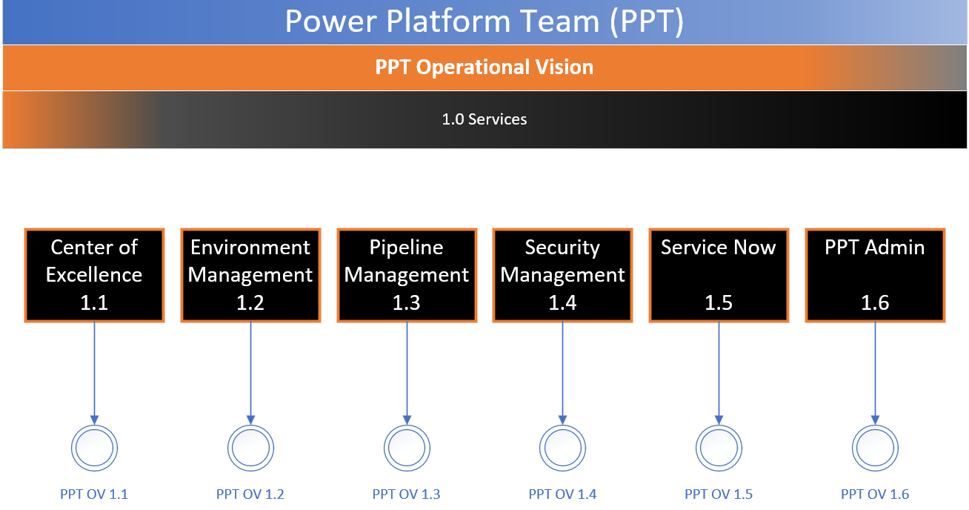

Figure 1: PPT Operational Vision 1.0 Services

Figure 1 shows the high-level operation services offered by the PPT. It is worth noting that we do not provide Power Application, Power Automate, Power BI, or any other power platform code assistance. While we do offer limited support, it is generally reserved for assisting Makers in understanding and how to manage their code for deployment between environments.

## PPT Operation Vision – 1.1 Center of Excellence

The Center of Excellence (COE) for the Power Platform is a Microsoft built tool for Power Platform Tenant Administrators use (See Figure below). It provides views and tools that span the entirety of the Power Platform Tenant of IRS, providing important information to assist the PPT Admins in keeping the Power Platform Environment healthy and informed. For example, the COE identifies orphan apps and flows easily without complex custom flows, as well as shows AI use across all of the tenant, app and flow use, and who it is shared with and more.

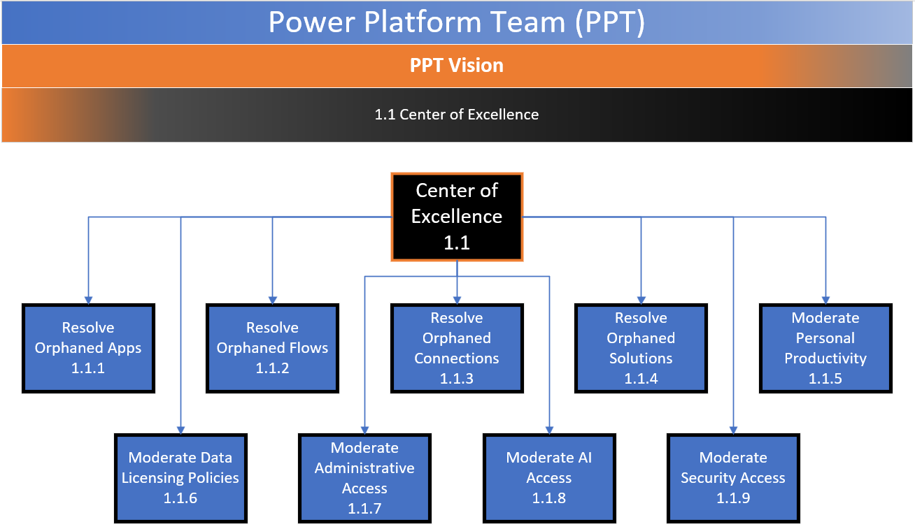

Figure 2: PPT OV 1.1

## PPT Operation Vision – 1.2 Environment Management

Environment Management is one of the core areas the PPT Admins spend a great deal of time. This allows the PPT Admins to create, update, and potentially remove environments. It also allows us to defined their environment Settings, assign their environments to a Data Licensing Policy (DLP), attach Entra Security Groups and provide the appropriate environment permissions (security roles), and more. It is the backbone of the environment that the IRS end users build their apps, flows, data flows, connections and more.

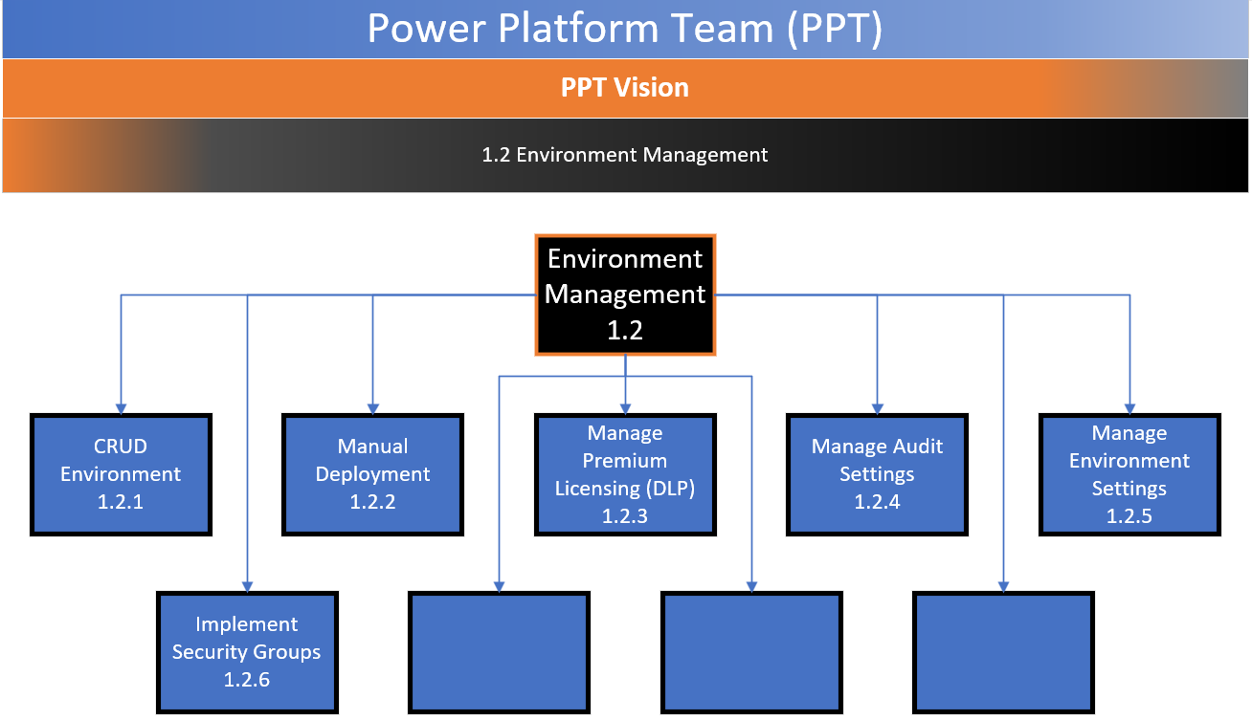

Figure 3: PPT OV 1.2[2]

## PPT Operation Vision – 1.3 Pipeline Management

Pipelines are offered by Microsoft within the Power Platform Environment as an additional Dynamics 365 application module. Pipelines offer a CI/CD (Continuous Integration / Continuous Delivery) feature within the Power Platform Environment, allowing developers to self-deploy from Sandbox (development) to Test and Production environments. Unfortunately, while the Pipeline feature is robust, it is not at the level of traditional CI/CD pipelines such as Azure DevOps or Team Foundation Server, or other more robust systems built to handle large-scale custom-built applications such as C++, JAVA, or C# application solutions. As such, there are some issues that require manual interaction by the PPT Admins in certain cases, such as when the user needs to deploy custom Security Roles. However, as these are not often modified once the system is ready to go to production, the interjection of PPT Admins within the pipeline is minimal compared to the developer’s self-deployment capabilities. It is hopeful that Microsoft will introduce a solution to negate this manual interjection in future Power Platform releases.

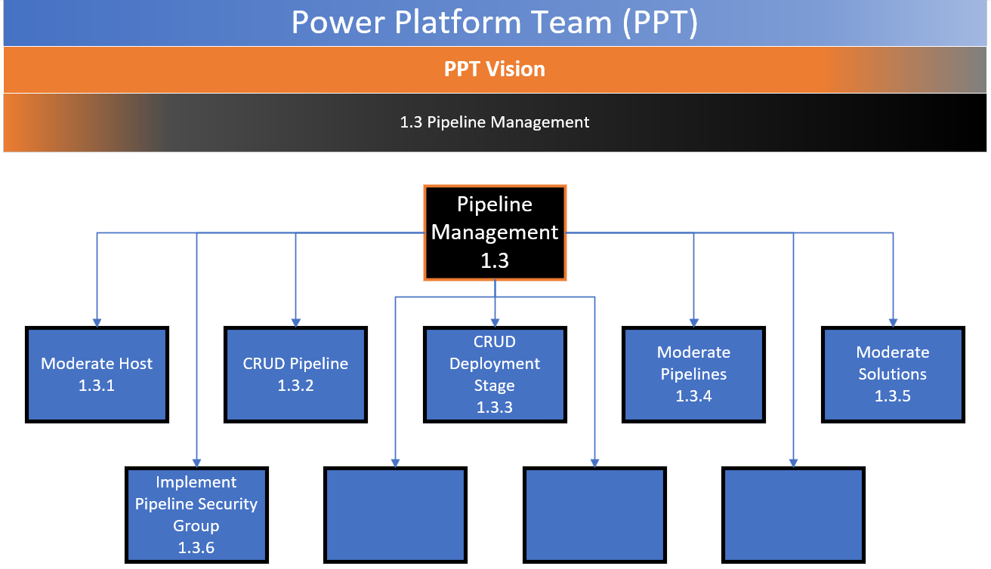

Figure 4: PPT OV 1.3[3]

## PPT Operation Vision – 1.4 Security Management

Security Management has two sides. The first side is security management for each Environment built. The PPT Admins create and maintain Entra Security Groups and attach them to “Teams” within each environment and apply the appropriate security roles. This may include Admins, Makers and Users in the Sandbox environment.; or Users and several custom Security groups for each of the custom Security Roles they have. It also includes the creation and attachment of Pipeline Deployment groups necessary to perform pipeline deployments. The second side is insuring that no one has been given inadvertent access to parts of environments or part of the Power Platform Environment. Specifically insuring that access and permissions are limited in the Personal Productivity (default) environment, and to ensure that people are not using the default environment to run production level flows, or apps.

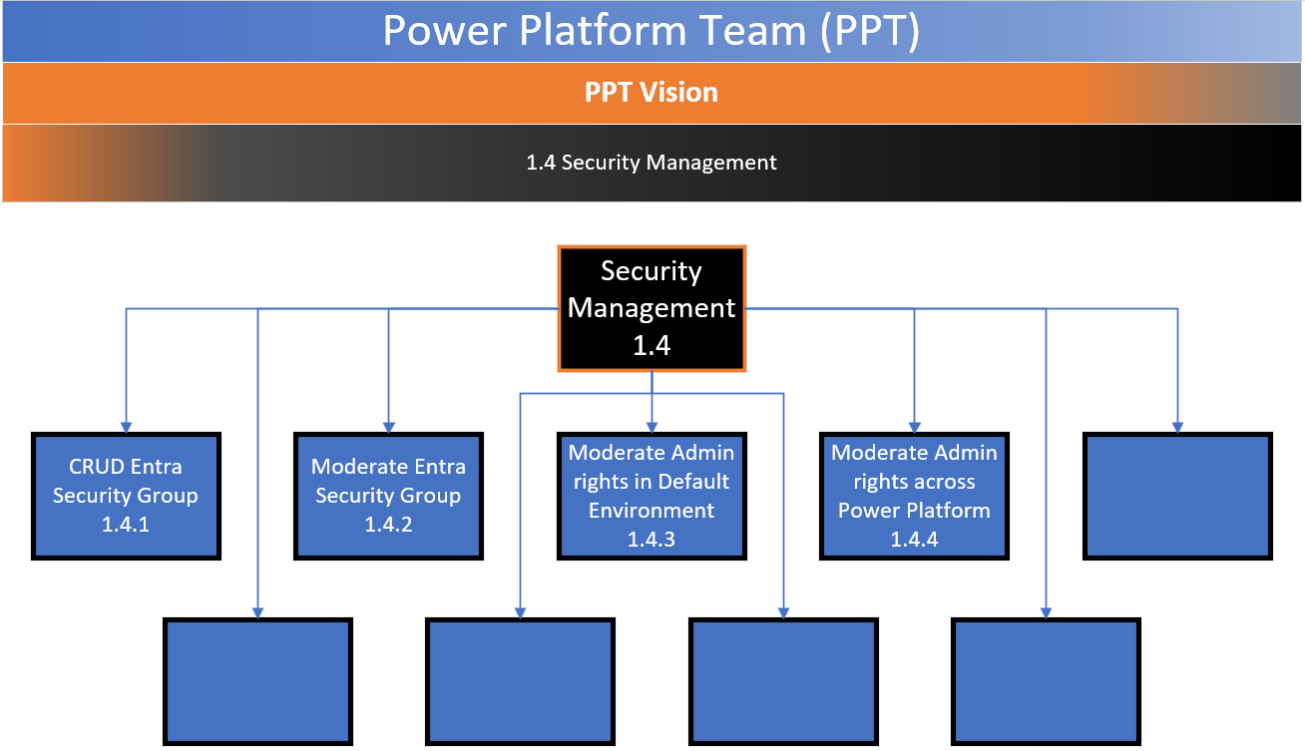

Figure 5: PPT OV 1.4[4]

## PPT Operation Vision – 1.5 Service Now

The PPT has a page and several forms that are specific to Power Platform. For example, we have a form specific for Environment requests, one specific to security groups, and another for deployment requests. We maintain those forms and we service the tickets that come from it, as well as additional tickets that are assigned to us that came through other means within Service Now.

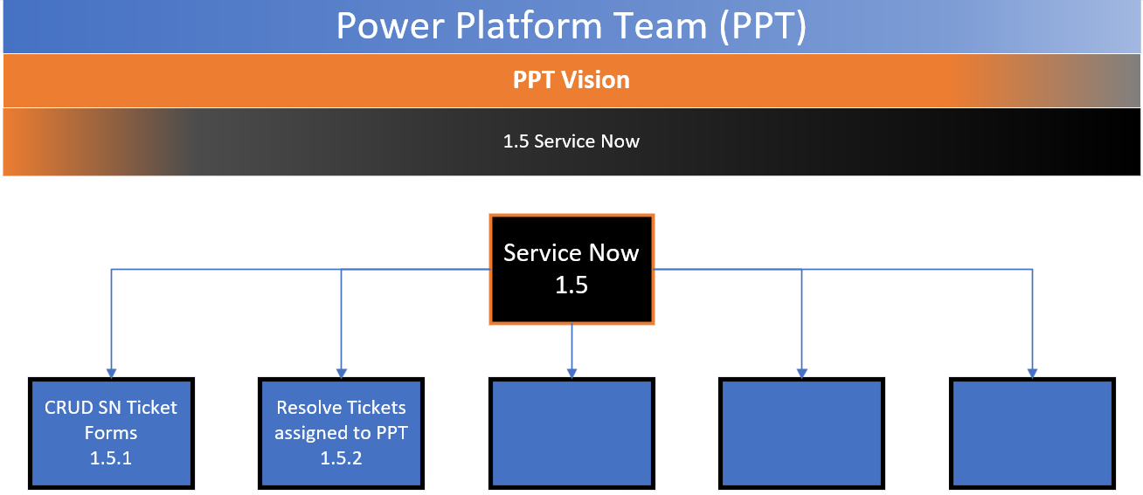

Figure 6: PPT OV 1.5

## PPT Operation Vision – 1.6 PPT Admin

The PPT will ensure that IRS users may access the latest information pertinent to the Power Platform Environment, instructions, governance, processes and all pertinent documentation and information applicable to the IRS end user (customer) will be available through the M365 Central SharePoint site Power Platform section.

The Team will also utilize the SharePoint site beneath the PPT Team site (TM-IT-EOPS-M365 Power Platform Project) to maintain core documentation pertinent to the PPT such as step-by-step procedures of “How to” perform the core actions that make up our Operational Objectives.

Finally, the PPT will also have a measure to display Metrics to various audiences (TBD). Some metrics will be maintained within a MS Project Spring template, which provides operational burndown charts, such as Sprint burndown, personnel utilization, and more. Furthermore, we will provide base metrics such as: Power Platform usage to management, such as total Environments, Total Apps, Total Flows, Personal Productivity burndown, and pipeline metrics. Many of these metrics may be internal to the development team (PPT), while others will be available to the PPG (including stakeholders).

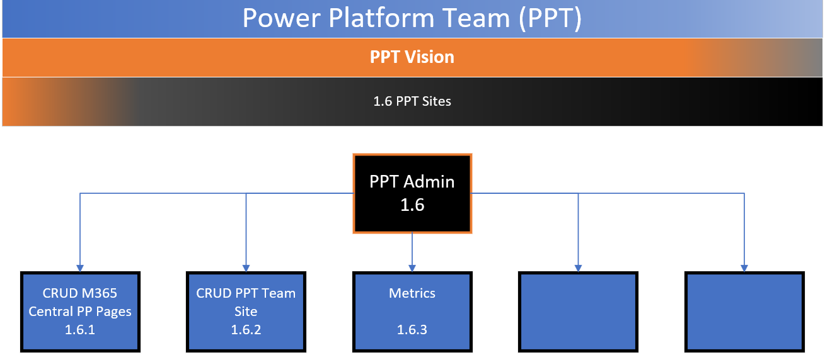

Figure 7: PPT OV 1.6

# Elements Of Governance

* Power Platform tenant-level Administration settings
* Individual Environments
  + Sandbox
  + Test
  + Production
  + Developer
  + Trial
  + Pipeline Host
* Microsoft Entra Security Groups
* Manual Deployments
* Pipelines
  + Host
  + Pipelines
    - Validation of Solution
      * Validation against architecture approval
    - Validation of UAT
    - Validation against app checker
  + Pipeline Deployment Groups
  + Special deployment accommodations for Security Roles
* COE Health and Monitoring
  + Ensure users are not using Default environment for production
  + Clean up Ghost objects
    - Apps
    - Flows
    - Connections
    - Environments
  + Monitor irregular behavior of apps, flows, or connections
  + Monitor irregular permissions.
  + Setting Solution Checker and App Checker requirements
* Solutions
  + Validating Architecture
    - TRB with Cyber and Privacy
    - Templated Architecture document
  + Setting Time and Version limits on re-validation of Architecture
  + Ensuring apps meet app checker

# Operational Use Cases

## Center Of Excellence (COE) 1.1

### Resolve Orphaned Apps 1.1.1

Every Sprint a check will be made to see if there are Orphaned Applications. Any identified orphaned applications will be mitigated through contacting users who the app is shared with, or if it is attached to a dedicated environment. For those applications that are ghost, we will work with Privacy to determine proper disposal.

### Resolve Orphaned Flows 1.1.2

Every Sprint a check will be made to see if there are Orphaned Flows. Any identified orphaned flows will be mitigated through contacting users who the flows is shared with, or if it is attached to a dedicated environment. For those flows that are ghost, we will work with Privacy to determine proper disposal.

### Resolve Orphaned Connections 1.1.3

Every Sprint a check will be made to see if there are Orphaned Connections. Any identified orphaned connections will be mitigated through contacting users who the connections are shared with, or if it is attached to a dedicated environment. For those connections that are ghost, we will work with Privacy to determine proper disposal.

### Resolve Orphaned Solutions 1.1.4

Every Sprint a check will be made to see if there are Orphaned Solutions. Any identified orphaned solutions will be mitigated through contacting users who the solutions are shared with, or if it is attached to a dedicated environment. For those solutions that are ghost, we will work with Privacy to determine proper disposal.

### Moderate Personal Productivity 1.1.5

The PPT will instill regulations and limitation on the Personal Productivity environment to ensure that users do not use it in a productive manner.

### Moderate Data Licensing Policies 1.1.6

To ensure that the DLP is being adhered to, the COE provides apps, flows and solutions that are operating outside of a DLP, which will be remediated appropriately. PPT will also regularly monitor changes in the premium licensing offerings to ensure that the IRS end users have access to the latest and greatest connectors within IRS licensing and Privacy/Cybersecurity approvals.

### Moderate Administrative Access 1.1.7

To ensure that users do not have unnecessary access to environments, or objects within the Power Platform Environment, the PPT will utilize the features of the COE to identify misuse or mis-appropriated power to individuals, and work to remedy the situation. Furthermore, in coordination with management, and other groups, ensure that no unauthorized rights are given to users into the COE or Power Platform Admin center, and that those who have access due to greater rights are not using those powers in a unknowingly bad means within the Power Platform Environment.

### Moderate AI Access 1.1.8

AI has not been approved for IRS but was briefly used in great quantities by several users and organizations early in the Power Platform adoption. The PPT will continue to vigilantly check any use of AI that circumvents the Power Platform Tenant AI settings.

### Moderate Security Access 1.1.9

Security Access is a crucial element, and is spread between several aspects of the PPT Services offered. In relation to the COE, it is determining who has advanced access to the COE, who has advanced or individual access to Environments (should be via Entra groups), and making sure that

## Environment Management 1.2

### CRUD Environment 1.2.1

One of the primary directives of the PPT is to create and modify Environments such as Sandbox, Test, and Production. This is done upon receiving a Service Now ticket, through the specific forms we have created.

Throughout the life cycle of the Environment, we will continue to monitor and manage the environment to ensure it stays within guidelines using the COE as a guide for identifying environments that may need adjustment or management based on COE findings, or at the request of end users and approval from necessary approvers.

### Manual Deployment 1.2.2

While it is the intent to have Pipelines fully flushed out and developed to allow groups to self-deploy, currently and even once the Pipelines are set up, there will be times where we will need to manually deploy.

### Manage Premium Licensing (DLP) 1.2.3

Whether or not the IRS acquires the necessary number of premium licenses for Power Platform for all of IRS or not, the PPT will continue to require Security Change Management approval before providing premium connector capability. This will ensure that all connectors that may point outside of IRS or connect to non-approved 3rd party software/services are vetted by Cyber and Privacy prior to being used.

### Manage Audit Settings 1.2.4

Audit settings are not immediately available when creating an Environment but must be modified afterwards when the environment synchronizes with the tenant. As such, the PPT will remain vigilant to ensure that the audit logs for each environment are retained for the proper length of time.

### Manage Environment Settings 1.2.5

When creating an environment, the environment settings are set (see *Instructions for Power Platform Environments.docx*) to ensure that the environment is secure and provides the end users with the appropriate capabilities.

### Implement Security Groups 1.2.6

Security groups are created to provide the necessary access (see *Instructions for Power Platform Environments.docx*). Sandbox environments allow maker and admin access, but the Test and Production environments are managed and allow only user and pipeline deployment access. Additional “User” groups may be created as necessary for any custom security roles related to the Dataverse tables that are implemented by the end user.

## Pipeline Management 1.3

### Moderate Host 1.3.1

The Host environment holds, maintains, and manages all the pipelines attached to it. Pipelines are defined with the host, and only exist within the host. PPT will maintain and manage the host and implement any necessary elements to monitor and provide approval and validation to pipeline deployments.

### CRUD Pipeline 1.3.2

The PPT will create, read (provide information), update and delete (remove) all pipelines within the host environment. The PPT will also monitor and manage the pipelines as necessary to ensure they remain healthy and up to date with necessary information.

### CRUD Deployment Stage 1.3.3

The PPT will provide CRUD operations in relation to Deployment Stages to ensure that all pipelines require deployment to Test prior to deploying to Production, and that all deployments stages across all pipelines follow standards laid out in the *Instructions for Power Platform Environments.docx* reference.

### Moderate Pipelines 1.3.4

The PPT will implement Power Automate Flows within the Host environment to monitor all Pipeline deployment requests. While the Host monitors and keeps a history or deployment runs itself, the PPT will use the flows to capture information to ensure that if deploying to production the deploying pipeline group must show that they have performed proper UAT. Failures will be recorded, and emails will be sent to our group to ensure that we are aware and can chase down the issue, as well as ensure success.

### Moderate Solutions 1.3.5

Using the same flows to intercede during the deployment process of pipelines, the PPT will ensure that the solution being deployed is a known and approved solution and has a valid approval status prior deployment.

### Implement Pipeline Security Group 1.3.6

Pipeline security is separate and only available once an environment(s) has been associated in a pipeline. Once it is associated, a new Pipeline Entra Security Group is created and attached to each environment of the Pipeline, as well as to the Host where the Pipeline is shared with that Pipeline group, and given the Pipeline Deployment User security role, allowing them to perform the pipeline deployment.

## Security Management 1.4

### CRUD Entra Security Group 1.4.1

This task is specific to our group and is directly related to the Environments. The PPT performs CRUD operations for the Entra Security groups that are associated with each environment, connecting them to their proper security roles on each environment.

### Moderate Entra Security Group 1.4.2

The PPT will monitor and ensure that Entra Groups are being used appropriately in relation to Power Platform environments. In some cases owners leave and the Entra groups have no owner, in which case we receive a Service Now ticket to have a new Owner added. We also use COE to identify when groups are given unnecessary access, or may be outside of normal operating guidelines.

### Moderate Admin Rights in Default Environment 1.4.3

The Personal Productivity (default) environment is widely used, and is available to all IRS personal with a G5 license. It allows them to create, update, delete and run Power Platform apps and flows, and more. Because the use of dedicated and BU specific environments came well after the default environment was released, there are hundreds if not thousands of apps and flows that users have created and many of them use them in production manner.

To combat this behavior, the PPT monitors usage and number of users on a app or flow. If it being used regularly or has a large or growing number of users, it is flagged and the PPT works with them to move the app or flow to a BU or dedicated environment.

### Moderate Admin Rights Across Power Platform 1.4.4

The PPT uses the COE, works with IRS licensing personnel, and monitors all Admin level groups to ensure that users are not given or taking advantage of unnecessary access to Power Platform administration.

## Service Now 1.5

### CRUD Service Now Ticket Forms 1.5.1

The PPT has several Service Now forms that were created for specific requests such as new Environments, new Security Groups, and deployments. The PPT will continue to review and determine if the forms need amendment, removal, or new forms are needed for specific requests.

### Resolve Tickets Assigned to PPT 1.5.2

The PPT continues to work Service Now tickets submitted for the Power Platform.

## Power Platform Website 1.6

### CRUD M365 Central PP Pages 1.6.1

The PPT team will perform CRUD operations and maintenance and monitoring of the M365 Central Power Platform section to ensure that the information remains relevant and up to date, and provides users with the necessary information and tools to use or make requests of the Power Platform Team.

### CRUD PPT Team Site 1.6.2

The PPT will monitor and maintain the SharePoint Site beneath the *TM-IT-EOPS-M365 Power Platform Project* team. Here, the PPT will provide operational information and metrics, as well as Power Platform metrics that are pertinent to both the development team (PPT) as well as the stakeholders (Power Platform Group (PPG)).

Relevant data such as PPT instructions and How To documents will be maintained here through the Team, making it a knowledge base as well for the PPT and PPG.

### Metrics 1.6.3

Metrics will be maintained to assist the PPT in quick looks access to see where the environment stands across many defining metrics. The PPG will also have metrics available that are more relevant to them to ensure they have a birds eye view of the operations of the PPT and the Power Platform Environment.

# Capabilities: Rules, Regulations and Responsibilities

The Capabilities outlined in this section correlate to the Operational Objectives, and are in the following form:

* Responsibilities: This defines the core responsibilities and tasks that the Power Platform Team is responsible for within the IRS environment.
* Rules: Regulations that define the thresholds, limits, and time frames of much of what the PPT does.
* Regulations: Regulations that guide the Power Platform Team in implementation of Power Platform tasks.

## Responsibilities

* 1. Center of Excellence (CoE)
  2. Environment Management
  3. Pipeline Management
  4. Security Management
  5. Service Now
  6. PPT Admin

# Future State of Power Platform Governance

While it seems like there is not a great deal to do to ensure governance is applied, the Power Platform Environment is a complex service that is wrapped and intertwined with

# Appendix A: Pipeline API Process

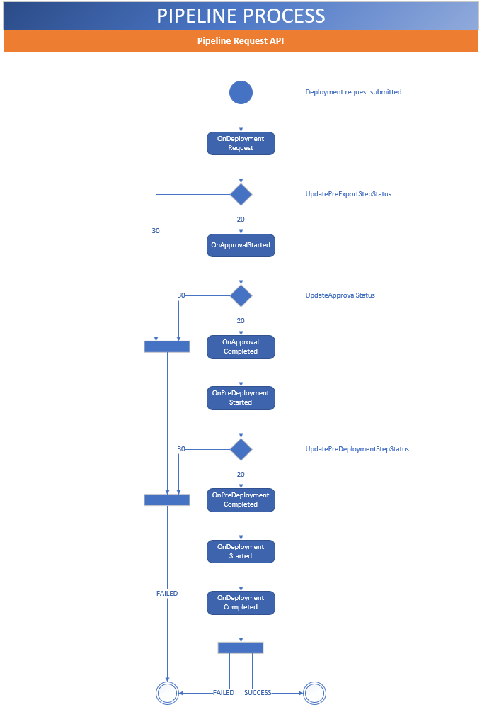

Figure 8

power platform and power apps need to be under real governance

-how they are created

-how they are managed

-change in ownership?

-use case scenarios? easy/med/difficult

1. what are we doing for pipelines today

2. what are we not doing?

3. any needed contract support or tool we could use?

Who approves the actual apps? documentation?

Need responses to these questions by COB Wednesday next week.

What are we doing?

What are we not doing?- app checkers? reviews?

What are we planning to do?

Are there other tools that we can use to help provide governance?

What results are we trying to achieve?

What are the use cases?

1. CRUD (or C.R.U.D.) means **C**reate, **R**ead, **U**pdate and **D**elete. It is a common terms used in software development.
2. The blank boxes are intentionally left there. This is still in review, and we left the boxes for future changes. They will be removed once the PPT/PPG agree on the images.
3. The blank boxes are intentionally left there. This is still in review, and we left the boxes for future changes. They will be removed once the PPT/PPG agree on the images.
4. The blank boxes are intentionally left there. This is still in review, and we left the boxes for future changes. They will be removed once the PPT/PPG agree on the images.